**Experiment: 1**

**Aim:** WAP using class Person to Display name and age.

**Software:** VS Code

**Code:-**

import java.util.*;

class Person

{

    String Name;

    int age;

}

public class Programm_1

{

    public static void main(String[] args)

    {

        Scanner sc = new Scanner (System.in);

        Person P1 = new Person();

        System.out.print("Enter Your Name:-");

        P1.Name = sc.nextLine();

        System.out.print("Enter Your Age:-");

        P1.age = sc.nextInt();

        System.out.println("Personn's Details:-\nName:- " + P1.Name + "\nAge:- " + P1.age);

    }

}

**Output:**

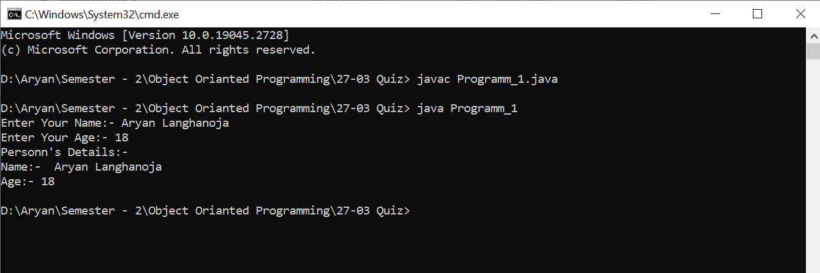

**Experiment: 2**

**Aim:** WAP using class Person to Display name and age with method.

**Software:** VS Code

**Code:**

import java.util.*;

class Person

{

    String Name;

    int age;

    public void Display(String Name,int age)

    {

        System.out.println("Personn's Details:-\nName:- " + Name + "\nAge:- " + age);

    }

}

public class Programm_2

{

    public static void main(String[] args)

    {

        Scanner sc = new Scanner (System.in);

        Person P1 = new Person();

        System.out.print("Enter Your Name:-");

        P1.Name = sc.nextLine();

        System.out.print("Enter Your Age:-");

        P1.age = sc.nextInt();

        P1.Display(P1.Name, P1.age);

    }

}

**Output:**

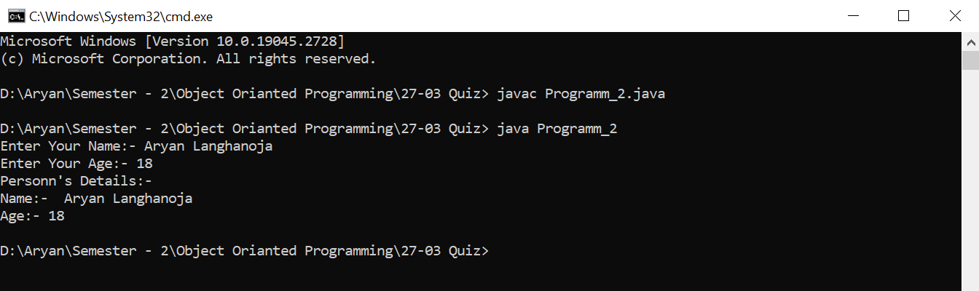

**Experiment: 3**

**Aim:** WAP using class Rectangle and calculate area of rectangle using method.

**Software:** VS Code

**Code:-**

import java.util.*;

class Rectangle

{

    Double Length;

    Double Breadth;

    public void calArea(Double Length,Double Breadth)

    {

        System.out.println("The Area Of Rectangel Is " + (double)Length*Breadth);

    }

}

public class Programm_3

{

    public static void main(String[] args)

    {

        Scanner sc =new Scanner(System.in);

        Rectangle R1 = new Rectangle();

        System.out.print("Enter The Length Of Rectangle:-");

        R1.Length = sc.nextDouble();

        System.out.print("Enter The Breadth Opf Rectangle:-");

        R1.Breadth = sc.nextDouble();

        R1.calArea(R1.Length, R1.Breadth);

    }

}

**Output:**

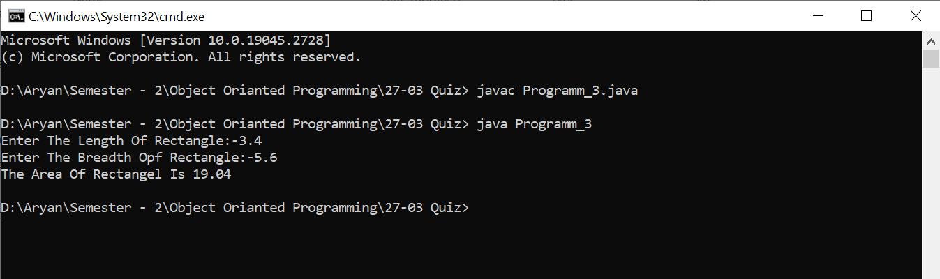

**Experiment: 4**

**Aim:** WAP using class Rectangle and calculate area of rectangle using method.

**Software:** VS Code

**Code:-**

import java.util.*;

class Square

{

    double Length;

    public void calArea(Double Length)

    {

        System.out.println("The Area Of Square Is " + (double)Length*Length);

    }

}

public class Programm_4

{

    public static void main(String[] args)

    {

        Scanner sc =new Scanner(System.in);

        Square S1 = new Square();

        System.out.print("Enter The Side-Length Of A Square:-");

        S1.Length = sc.nextDouble();

        S1.calArea(S1.Length);

    }

}

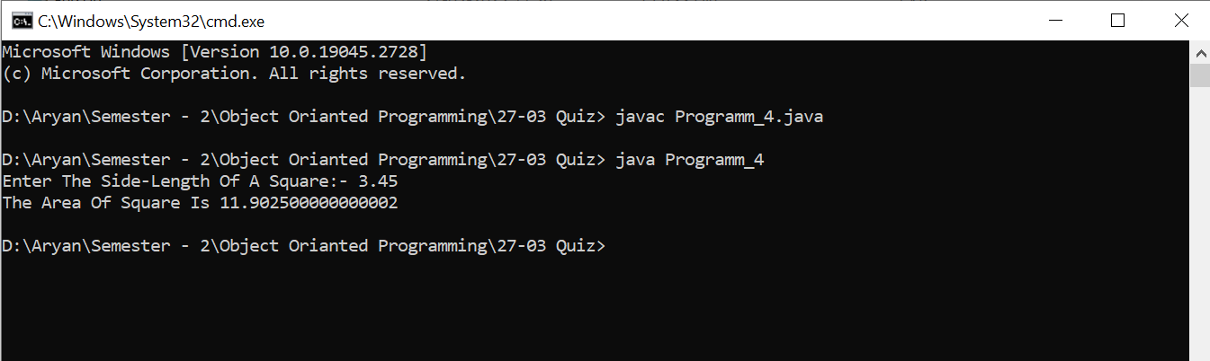**Output:**

**Experiment: 5**

**Aim:** WAP using class Circle and calculate area of Circle using method.

**Software:** VS Code

**Code:**

import java.util.*;

class Circle

{

    long Radius;

    public void calArea(long Radius)

    {

        System.out.println("The Area Of Square Is " + 3.14159*Radius*Radius);

    }

}

public class Programm_5

{

    public static void main(String[] args)

    {

        Scanner sc =new Scanner(System.in);

        Circle C1 = new Circle();

        System.out.print("Enter The Radius Of A Circle:-");

        C1.Radius = sc.nextLong();

        C1.calArea(C1.Radius);

    }

}

**Output:**

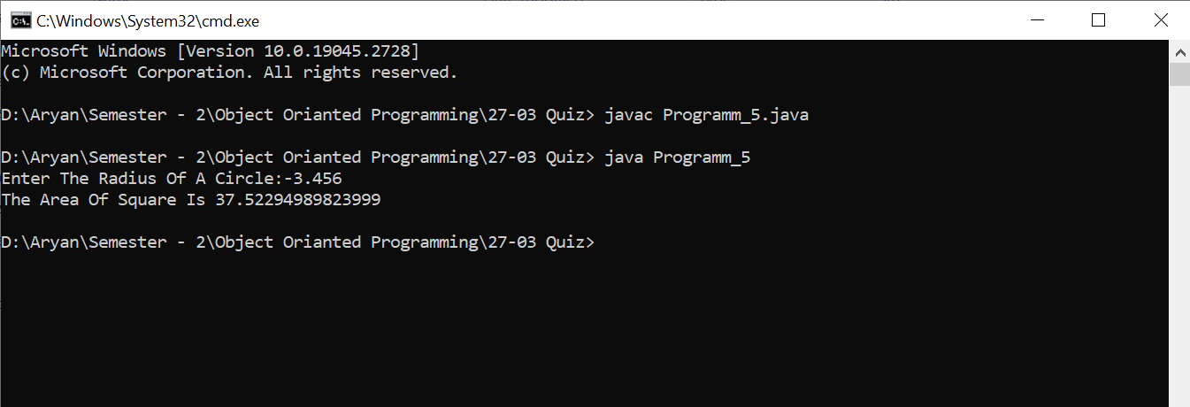

**Experiment: 6**

**Aim:** WAP using class Interest and calculate Simple Interest using method.

**Software:** VS Code

**Code:-**

import java.util.*;

import javax.sql.rowset.spi.SyncResolver;

class Interest

{

    long Principle_Amount;

    int No_Of_Years;

    float Rate_of_Interest ;

    public void calInterest(long Principle_Amount,int No_Of_Years,float Rate_of_Interest)

    {

        System.out.print("Simple Interest On Rs." + Principle_Amount+ "/- For " + No_Of_Years + " Years At " + Rate_of_Interest + "% Is " + (Principle_Amount*No_Of_Years*Rate_of_Interest)/100);

    }

}

public class Programm_6

{

    public static void main(String[] args)

    {

        Scanner sc =new Scanner(System.in) ;

        Interest I1 = new Interest();

        System.out.print("Enter The Principle Amount:-");

        I1.Principle_Amount = sc.nextLong();

        System.out.print("Enter The Number Of Years:-");

        I1.No_Of_Years = sc.nextInt() ;

        System.out.print("Enter The Rate Of Interest:-");

        I1.Rate_of_Interest = sc.nextFloat() ;

        I1.calInterest(I1.Principle_Amount,I1.No_Of_Years,I1.Rate_of_Interest) ;

    }

}

**Output:**

